**Upliance.AI Assignment**

**Correlation Analysis: Session Rating vs. Order Rating:**

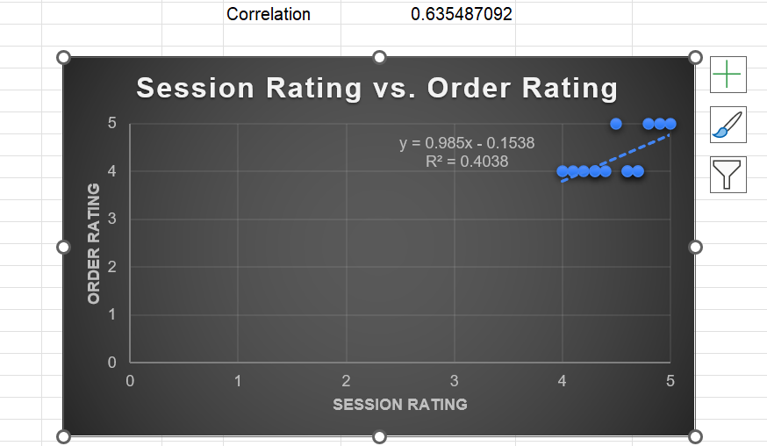

The correlation coefficient (**r**) of **0.63** indicates a **moderate positive correlation** between the two variables: **Session Rating** and **Order Rating which is not extremely strong but the value is positive** it means if session rating increases then order rating will also get increase

**Summary of Scatter Plot Insights:**

* A scatter plot helps visualize the **relationship** between two numerical variables.
* Adding a **trendline** makes it easier to identify correlations (positive, negative, or none).
* **R-squared value** helps quantify how well the data fits the trendline (high R-squared means a stronger correlation).

**Recommendations:**

1. **Enhance Cooking Sessions:** Improve clarity, personalization, and engagement to boost session quality.
2. **Address Other Factors:** Focus on delivery speed, dish accuracy, and quality to increase satisfaction.
3. **Target High-Rating Users:** Offer promotions to users with high session ratings to encourage repeat orders.

**Summary of Meal Type Analysis:**

Meal Type Analysis:

* **Grilled Chicken** and **Spaghetti** are the most popular dishes, each with **4 orders**.
* **Caesar Salad** follows with **3 orders**.
* **Pancakes** and **Veggie Burger** received **2 orders** each.
* **Oatmeal** received the lowest count with only **1 order**.

Recommendations:

* Highlight **Grilled Chicken** and **Spaghetti** in promotions or meal bundles to attract more users and capitalize on their popularity.
* Consider improving the appeal of **Oatmeal** through enhanced recipes, better presentation, or pairing it with a complementary dish.

**Summary of Meal Preferences by Age Group:**

**Key Findings**

* **30-40 Age Group:** Most diverse preferences; top choices include **Caesar Salad** and **Spaghetti** (2 each).
* **Under 30:** Strong preference for **Grilled Chicken** and **Spaghetti** (2 each), favoring protein-rich meals.
* **Over 40:** Least diverse; limited to **Pancakes** and **Veggie Burger** (1 each), requiring better engagement.

**Insights**

* **Spaghetti** and **Grilled Chicken** are universally popular.
* **Under 30:** Prefer hearty meals; **30-40:** Broad tastes; **Over 40:** Limited engagement.

**Recommendations**

1. **Promote Popular Dishes:** Focus on **Spaghetti** and **Grilled Chicken** with meal bundles.
2. **Age-Specific Offers:**
   * **30-40:** Diverse options like salads and burgers.
   * **Under 30:** Highlight protein-rich meals.
   * **Over 40:** Offer health-focused, customizable meals.
3. **Revitalize Low-Performers:** Improve **Oatmeal** and **Pancakes** with healthier, customizable options.
4. **Re-engage Over 40:** Use personalized strategies emphasizing quality and convenience.
5. **Monitor Trends:** Regularly review sales to refine menu offerings.

**Summary of Meal Preferences by Location:**

**Findings**

* **Location Insights:** Certain locations show higher engagement, with popular dishes like **Spaghetti** and **Grilled Chicken** performing well across demographics.
* **Menu Preferences:**
  + **Urban Locations:** Favor diverse options like **Caesar Salad**, **Spaghetti**, and **Grilled Chicken**.
  + **Suburban Areas:** Preference for simpler meals like **Pancakes** and **Veggie Burgers**.
* **Low-performing Dishes:** **Oatmeal** and **Pancakes** show limited appeal across all locations.
* Customers from New York and Los Angeles exhibit a diverse range of meal preferences

**Recommendations**

* Promote **Spaghetti** and **Grilled Chicken** with location-specific combos.
* Tailor offerings: **Urban** – premium options; **Suburban** – comfort foods.
* Revamp **Oatmeal** and **Pancakes** with healthy add-ons.
* Use location-based marketing to highlight favorites.
* Monitor trends to adjust menu and improve engagement.